1/4/2022

Mobile Application Development

Lab Manual 8

Safdar Hussain, BSCS-VII-A

CMS: 023-18-0059

Lab8

MainActivity.java

package com.example.myapplication;  
  
import androidx.appcompat.app.AppCompatActivity;  
  
import android.os.Bundle;  
import android.os.SystemClock;  
import android.view.View;  
import android.widget.Chronometer;  
  
public class MainActivity extends AppCompatActivity {  
 private Chronometer chronometer;  
 private boolean running;  
 @Override  
 protected void onCreate(Bundle savedInstanceState) {  
 super.onCreate(savedInstanceState);  
 setContentView(R.layout.*activity_main*);  
 chronometer = findViewById(R.id.*chron*);  
 }  
  
 public void Start(View view){  
 if(!running){  
 chronometer.start();  
 running=true;  
 }  
 }  
  
 public void Stop(View view){  
 if(running){  
 chronometer.stop();  
 running=false;  
 }  
 }  
  
 public void Reset(View view){  
 chronometer.setBase(SystemClock.*elapsedRealtime*());  
 chronometer.start();  
 running=true;  
 }  
  
}

activitymain.xml

*<?*xml version="1.0" encoding="utf-8"*?>*<androidx.constraintlayout.widget.ConstraintLayout xmlns:android="http://schemas.android.com/apk/res/android"  
 xmlns:app="http://schemas.android.com/apk/res-auto"  
 xmlns:tools="http://schemas.android.com/tools"  
 android:layout_width="match_parent"  
 android:layout_height="match_parent"  
 tools:context=".MainActivity">  
  
 <RelativeLayout  
 android:layout_width="match_parent"  
 android:layout_height="match_parent"  
 tools:layout_editor_absoluteX="-16dp"  
 tools:layout_editor_absoluteY="16dp">  
  
 <Chronometer  
 android:id="@+id/chron"  
 android:layout_width="289dp"  
 android:layout_height="251dp"  
 android:layout_above="@+id/button6"  
 android:layout_alignParentTop="true"  
 android:layout_alignParentEnd="true"  
 android:layout_alignParentRight="true"  
 android:layout_marginTop="173dp"  
 android:layout_marginEnd="76dp"  
 android:layout_marginRight="76dp"  
 android:layout_marginBottom="194dp"  
 android:gravity="center"  
 android:textSize="36sp" />  
  
 <Button  
 android:id="@+id/button5"  
 android:layout_width="110dp"  
 android:layout_height="62dp"  
 android:layout_alignParentEnd="true"  
 android:layout_alignParentRight="true"  
 android:layout_alignParentBottom="true"  
 android:layout_marginTop="0dp"  
 android:layout_marginEnd="230dp"  
 android:layout_marginRight="230dp"  
 android:layout_marginBottom="131dp"  
 android:onClick="Start"  
 android:text="Start" />  
  
 <Button  
 android:id="@+id/button6"  
 android:layout_width="wrap_content"  
 android:layout_height="64dp"  
 android:layout_alignParentEnd="true"  
 android:layout_alignParentRight="true"  
 android:layout_alignParentBottom="true"  
 android:layout_marginEnd="139dp"  
 android:layout_marginRight="139dp"  
 android:layout_marginBottom="130dp"  
 android:onClick="Stop"  
 android:text="Stop" />  
  
 <Button  
 android:id="@+id/button7"  
 android:layout_width="114dp"  
 android:layout_height="64dp"  
 android:layout_alignParentEnd="true"  
 android:layout_alignParentRight="true"  
 android:layout_alignParentBottom="true"  
 android:layout_marginEnd="24dp"  
 android:layout_marginRight="24dp"  
 android:layout_marginBottom="129dp"  
 android:onClick="Reset"  
 android:text="Reset" />  
 </RelativeLayout>  
</androidx.constraintlayout.widget.ConstraintLayout>

Output

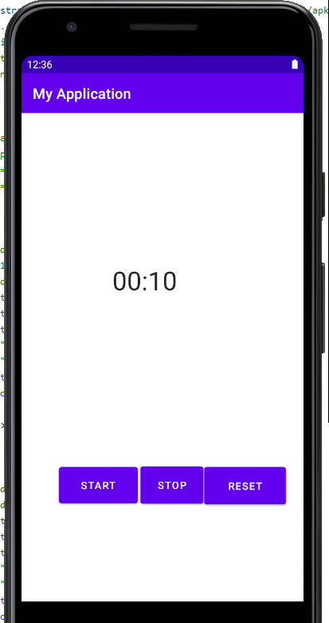

Activity 2:

MainActivity.java

package com.example.myapplication;  
  
import androidx.appcompat.app.AppCompatActivity;  
  
import android.os.Bundle;  
import android.view.View;  
import android.view.animation.Animation;  
import android.view.animation.AnimationUtils;  
import android.widget.Button;  
import android.widget.ImageView;  
  
public class MainActivity extends AppCompatActivity {  
 ImageView img;  
 Button toogleButton;  
 Thread thread;  
 @Override  
 protected void onCreate(Bundle savedInstanceState) {  
 super.onCreate(savedInstanceState);  
 setContentView(R.layout.*activity_main*);  
 img = findViewById(R.id.*imageView*);  
 toogleButton = findViewById(R.id.*button*);  
 thread = new Thread();  
 }  
  
 public void start(View view){  
 Animation move = (Animation) AnimationUtils.*loadAnimation*(getBaseContext(), R.anim.*rotate*);  
 img.startAnimation(move);  
 }  
}

activity_main.xml

*<?*xml version="1.0" encoding="utf-8"*?>*<androidx.constraintlayout.widget.ConstraintLayout xmlns:android="http://schemas.android.com/apk/res/android"  
 xmlns:app="http://schemas.android.com/apk/res-auto"  
 xmlns:tools="http://schemas.android.com/tools"  
 android:layout_width="match_parent"  
 android:layout_height="match_parent"  
 tools:context=".MainActivity">  
  
 <ImageView  
 android:id="@+id/imageView"  
 android:layout_width="173dp"  
 android:layout_height="153dp"  
 android:layout_marginTop="116dp"  
 app:layout_constraintEnd_toEndOf="parent"  
 app:layout_constraintStart_toStartOf="parent"  
 app:layout_constraintTop_toTopOf="parent"  
 app:srcCompat="@drawable/icon" />  
  
 <Button  
 android:id="@+id/button"  
 android:layout_width="wrap_content"  
 android:layout_height="wrap_content"  
 android:layout_marginTop="108dp"  
 android:onClick="start"  
 android:text="Rotate Button"  
 app:layout_constraintBottom_toBottomOf="parent"  
 app:layout_constraintEnd_toEndOf="parent"  
 app:layout_constraintHorizontal_bias="0.535"  
 app:layout_constraintStart_toStartOf="parent"  
 app:layout_constraintTop_toBottomOf="@+id/imageView"  
 app:layout_constraintVertical_bias="0.0" />  
</androidx.constraintlayout.widget.ConstraintLayout>

Rotation.xml

*<?*xml version="1.0" encoding="utf-8"*?>*<set xmlns:android="http://schemas.android.com/apk/res/android">  
 <rotate  
 android:fromDegrees="0"  
 android:toDegrees="360"  
 android:pivotX="25%"  
 android:pivotY="25%"  
 android:duration="5000" />  
</set>

